**Simplified Quadtree Image Segmentation**

*G.R. Conde Márquez, Hugo Jair Escalante, Luis Enrique Sucar*

There are many different types of possible ways to annotate images. In the Quadtree image segmentation technique, it was proposed to divide the image in homogeneous segments by merging adjacent regions using border and color information was Highly Effective and provide segmentation of acceptable performance suitable for time restricted scenarios.

In the proposed method, it was divided the segment process in five stage **(1) Edge detection, (2) Border processing, (3) Color discretization, (4) Quadtree scanning, (5) Segmentation enhancement**.

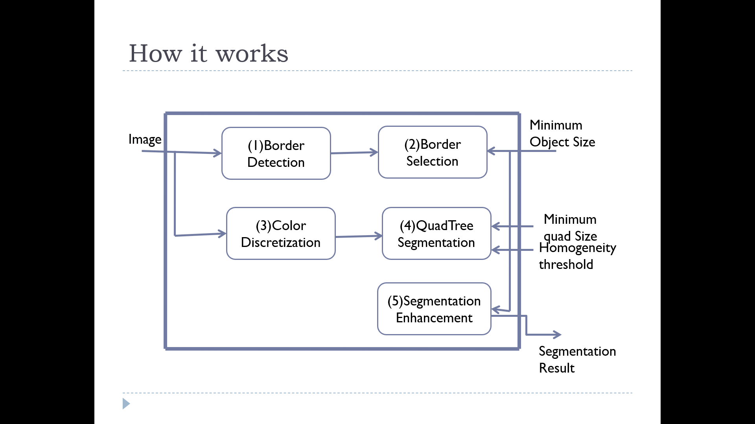

**Figure: Functional model of this proposal**

Now what we know about is that Quadtree is a [tree data structure](https://en.wikipedia.org/wiki/Tree_data_structure) in which each internal node has exactly four children. Quadtrees are the two-dimensional analog of [octrees](https://en.wikipedia.org/wiki/Octree) and are most often used to partition a two-dimensional space by recursively subdividing it into four quadrants or regions and it was first introduced by Hanan Samet. Here, all the blocks are disjoint and predefined sizes according to the base quad size. The item to be partitioned is the root Quadtree which is recursively partitioned according to predefined criteria.

At first edge detection, they have used Sobel operator which is a simple and straight forward method to detect image border and it was used to keep only the highest value. Secondly in border selection, border relevance is measured by its continuity and length where applied the connected components algorithm to the Sobel result and calculated the area of each component that was called those images *Constraints Image*. Thirdly in color discretization, they created 6 bits with color copy of the image 2 bits per each RGB component for normalizing and comparing. Fourthly, which was the main step the Quadtree segmentation part where the image is divided into four regions and each of them were compared with their adjacent 4-neighbors using a comparison operator and they will be merged if they are evaluated similar. The regions which are not merged with other regions will follow this process recursively until there are no more region to divide or the region size has reached the *mqs* parameter. If there are no border compatibility is found as non-similar then extract color histogram from each region then normalize and eliminate noise in them and calculate the Euclidean distance between the histograms. Through this process, it will help them to produce more homogeneous or noise free segment. Lastly, segmentation enhancement follows two steps to improve segmentation first applies comparison operator and second segment that do not meet the *mos* parameter and merges them with the similar most adjacent segment.

As they basically focused on the time complexity and the complexity of the whole process of the project was *O(N) = N+√N,* where *N = w+h* is the number of pixels of the image. This can be considered as efficient as the most segment algorithms of order *O(N2)* or even more than that.

To evaluate the segmentation performance of this method where first one consists of 18 heterogeneous manually selected images; second one consists of 100 randomly selected images from the Berkeley Segmentation Dataset; third dataset consists of 14 images randomly selected from “Image of the Day” Wikipedia section. the annotation for the annotation performance was evaluated with a dataset consisting of 500 images taken from the SAIAPR TC-12, which is a benchmark of manually segmented and annotated images.

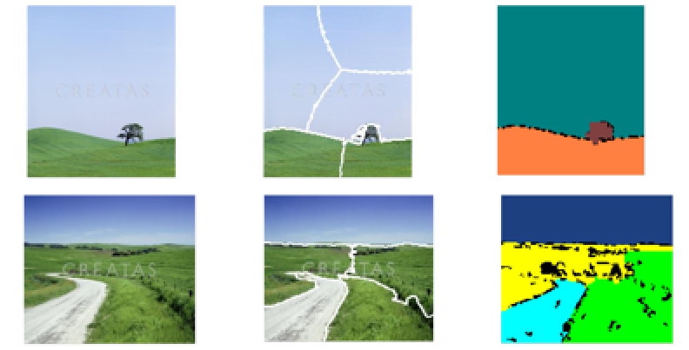

**Figure: Visual result of the functional model**

The proposal has two different segmentation Algorithm used in state-of-the-art image annotation: normalized cuts and grid segmentation. Here, normalized cuts consist of building a weighted graph from the image is which each node represent a pixel and the arc value and greet segmentation consists of cutting the image by grid of n rows and m columns of equal size. They got 0.75 points where it was correctly annotated. We can say that 75% of the total image area from 500 images. In their proposed method got more accurate than those generated with normalized cuts where it correctly identifies homogeneous segments. Quadtree segmentation algorithm 50% better than grid segmentation, 35% better than generated normalized and it was 17 faster than normalized cuts. It was a simple and efficient method for image segmentation and it can be implemented as in order for more speed.

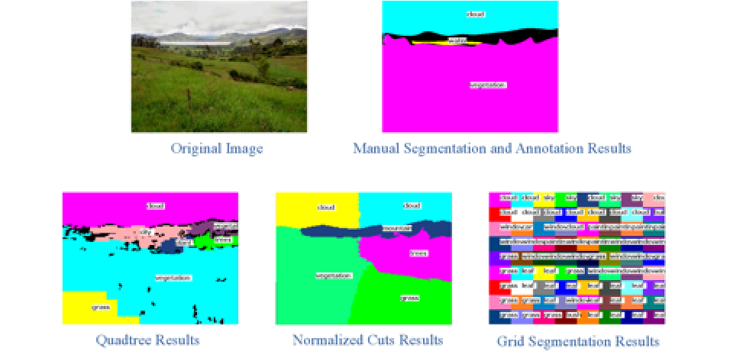

**Figure: Results obtained with the proposed quadtree segmentation algorithm**

**Reference:**

1. <https://www.academia.edu/2831795/Simplified_Quadtree_Image_Segmentation_for_Image_Annotation?fbclid=IwAR0x6twPX_3EqVO9fOB76c-iUNKV6kuMrhMSf0rdXe0M9-ZM-ZcriqlJemQ>